Ashley Rakahuri River Annual Bird Survey Report, 18 November, 2023
The below graphs summarize the numbers of the species (other than black-billed gulls) that we are most interested in. BBG are not included as the numbers can be highly erratic from year to year – from tens to over a thousand. These numbers are from the Okuku junction to State Highway One.
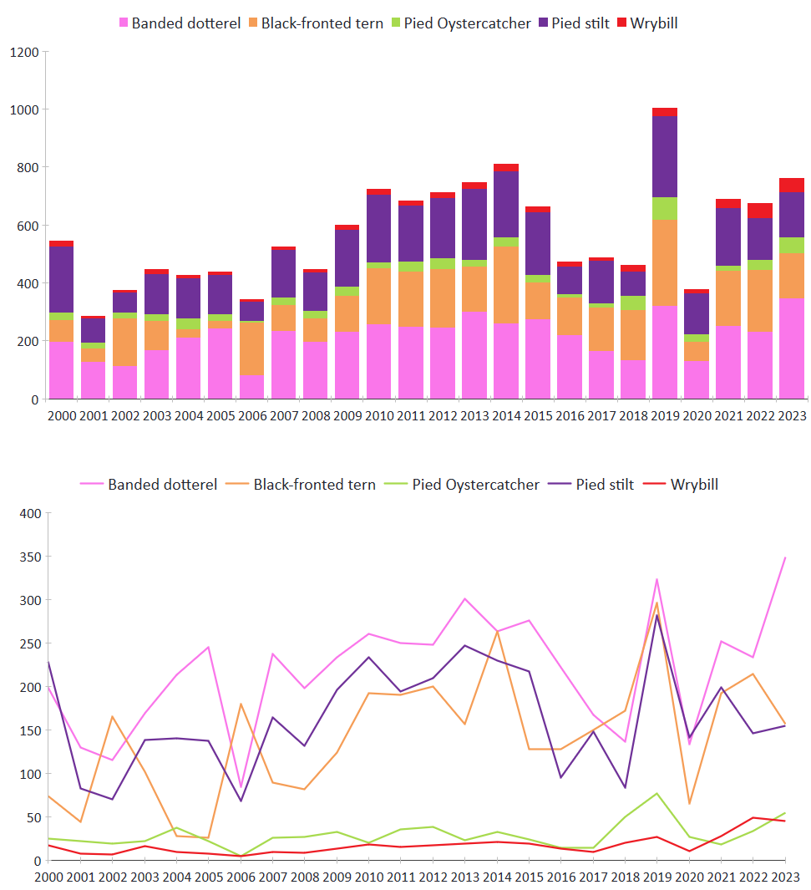
Some comments:
- Total braided river bird numbers were very good, slightly up on those from the last two years. However fledgling percentages give a much better indication of success or failure than annual count numbers.
- We were worried about the very low black-fronted tern numbers this season in parts of the river (e.g. Groyne 2 and Smarts) where they are usually abundant. The survey numbers were down from last year, but not nearly as much as feared. This was because of new colonies found in unexpected parts of the river. A small colony of about ten nests is present at the Okuku junction, and a much large one of perhaps 30 nests is near the Toppings Road access to the river. A third colony is just downstream from the railway bridge, we were aware of this one before the count. We don’t have trap lines near the newly discovered colonies, but there are no signs of predation so far. A cat has been eating chicks at the railway colony.
- Wrybill numbers were very similar to those of last year – at near historic highs. However, many of these birds do not appear to have nested here – and they may have been displaced by flooding on the Waimakariri. The season started as per normal with birds observed on the river from late August and the first nests found in mid-September. Many but not all of the 10 birds colour banded in the last two years (and B(WBW)) had returned. From mid-October, on several occasions in several locations, groups of at least 3 pairs were seen feeding and chasing each other – none of these birds were banded. This situation has continued, with the new pairs often being within the nesting territories of earlier arrivals. They seem to be moving around a lot. For example, both Nick and I visited the Swamp Road area not long before the annual count. We both saw 1 wrybill. On the annual count 9 were seen here. The day before the survey 11 wrybill were seen at Smarts, on the survey the number was much lower. Recently wrybill have also been seen in unusual places – e.g. 2 at the Okuku junction and 1 at Toppings.
- Banded dotterel numbers were at a record high. Pied oystercatcher numbers were up, and pied stilt numbers were similar to last year. BBG have behaved extremely erratically this year, but there is a very small colony downstream from the railway bridge and another seems to be developing at Toppings. Only 17 BBG were counted on the survey, but on 23 November there were approximately 250 at Toppings.
The maps below depict where the birds were seen in 2023 and 2022.
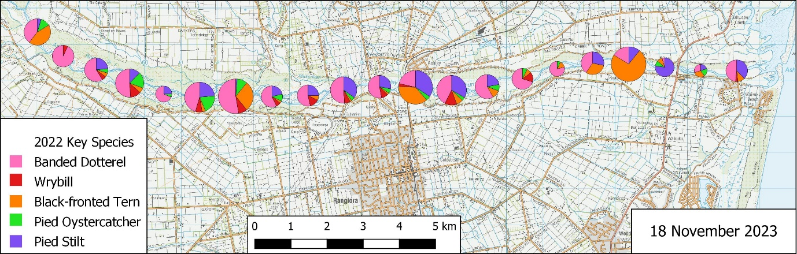
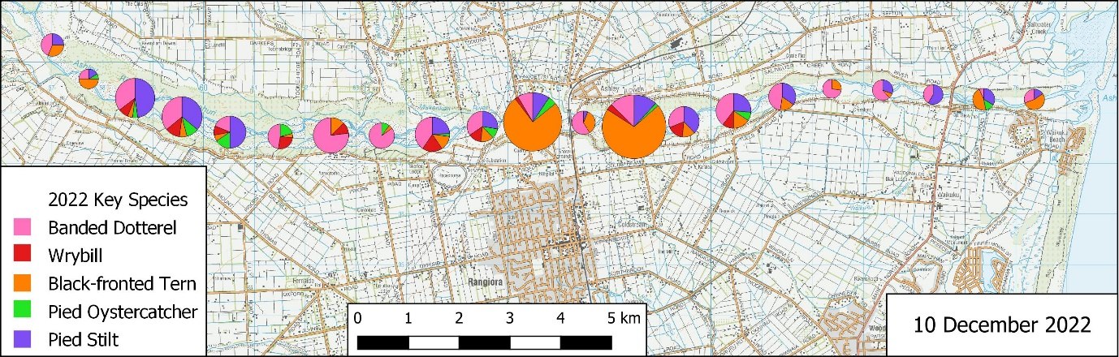
Grant Davey, 23/11/23

